IPhone 11 Max Pro (Purple)

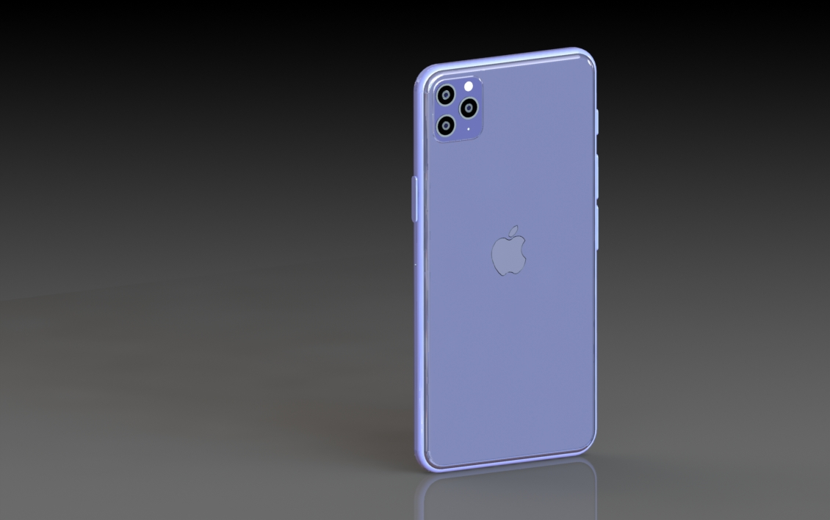

Paul Lopez
Cedarcrest High School
12/5/19

- Introduction (2 points)
  - Introduction paragraph(s) gives an overview of the project. Tell what the project is in general and specific terms. I pretty much just made a replica as best as I could of the iPhone 11 Pro max but instead of having a plain black, gold, or white color I made it purple like one of the iPhone 11 pro models. I dimensioned everything as best as I could and used a lot of extrusions and cuts and filets, overall fun and great experience making this project. Took around 3 weeks to complete or less, added textures, colors, background, and little gadgets the iPhone 11 has.

- Target Market (2 points)
  - Give a description of who would use the product and / or a customer list. (It could be a design for one specific user.) iPhone 11 Pro Max feature the toughest glass ever in a smartphone and are rated IP68 for water resistance up to 4 meters for up to 30 minutes and are protected against everyday spills including coffee and soda. This is designed for those people who are clumsy and always in a rush to something. The iPhone 11 has featured a new triple-camera system provides a pro-level camera experience with an Ultra-Wide, Wide and Telephoto camera, delivering huge improvements to low-light photography and offering the highest quality video in a smartphone that is great for shooting action videos. This is designed for someone who likes to take extradentary vivid pictures of whatever they pleasure. Each camera in the triple-camera system records brilliant 4K video.

- Success in Creating Product (16 points)
  - Answer the question: How successful were you in creating the product?
  - Give lessons learned (at least 2). Such as what you would do again (2). What you would not do again (2).
  - Give specific and appropriate supporting details (12). Use as many paragraphs as needed to fully explain. (You may also embed screen shots.) Nothing was really out of my skill level on solid works, everything was straight forward, had no big problems that I encountered, except for using a center line to make my apple logo vertical to the midpoint. I learned to not slack on project like this because it is very time consuming and trying to get everything perfect definitely takes time, I learned to just stay focused and work constantly on the project. I would take as long as I did try to get the colors perfect because that just wasted my time and I need to learn how to use the coloring more so that I completely understand it next time. For example, I couldn’t figure out a faster way to select every surface I wanted to color the same color or add the same texture to so that consumed my time.

- Product Sketches and Ideas (8 points)
  - Along with the sketches, you need to talk about the ideas that led to the sketches. The sketches themselves are worth 2 points of the 8 for the section.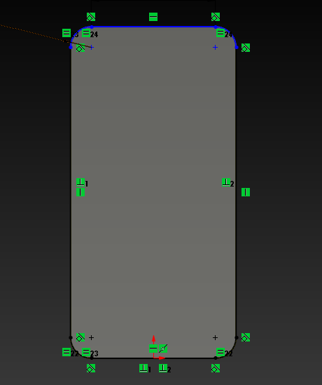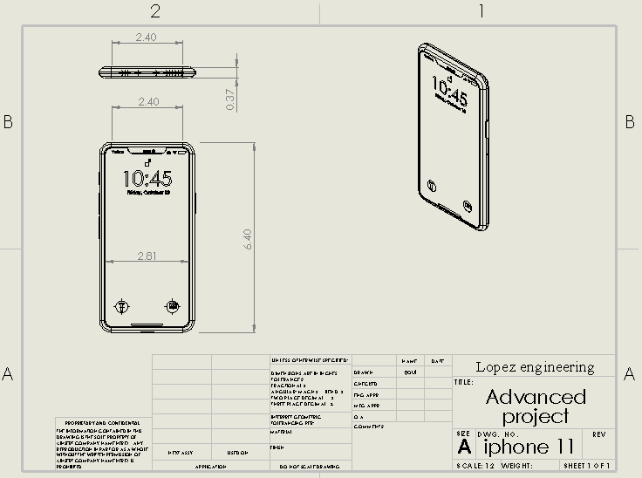I made a lot of tangent and equal relations to try and make everything as neat as I could. I want invest in the new iPhone and I was really interested and amused with how far apple has come with they’re new technology and that’s what led to this project.

  - Describe how you decided on the project (2), what requirements you decided on (2), and how you met those requirements with your design (2). I decided on this project because I wanted to make every that APPLE has came out with and that inspired me to try to create everything they have released. Im not done making every apple product but that’s going to be my goal by the end of the year.

- Product Drawings (8 points)
  - You need product drawings (6 points). Along with the drawings, give some explanation of what the drawings are (2). I smart dimensioned everything and made a front view, side view, top view and angled view. 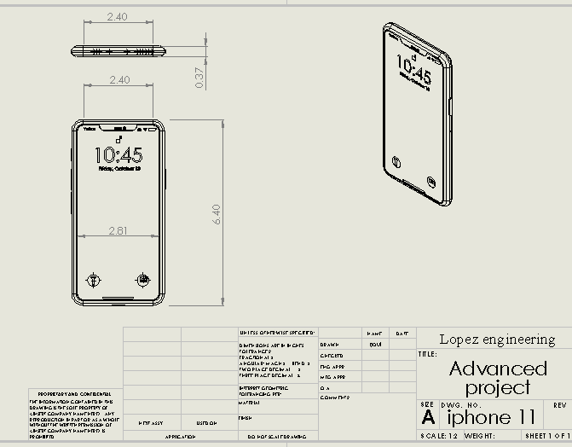

  - Product Renderings and/or Physical Models (4 points)
  - Put together enough renderings to show off your product. (3) These renderings (and /or pictures of physical models) must show case the product in the best light for customers or potential customers to want to obtain the product. Also give a short explanation of how you would go about appealing to customers (1).

  - 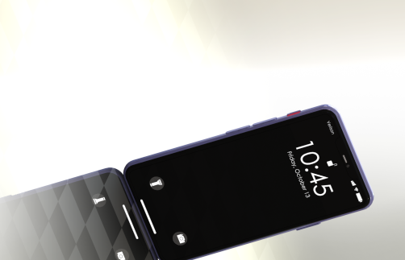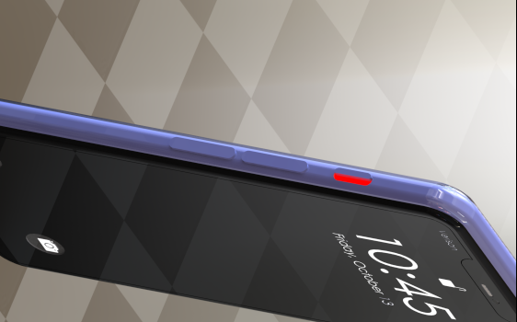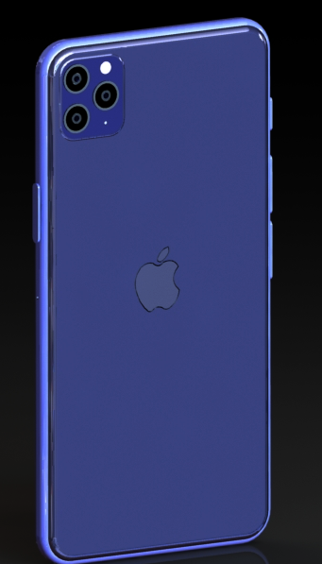
  - I would start my product off at a reasonable price and go on from there and explain the third camera and great camera feature and explain the good durability of the phone.

Appendix/Notes

You can put other notes or thoughts into the Appendix/Notes section. These are thoughts or notes that do not fit into the other categories but add to the understanding of the product. The Appendix/Notes section may be deleted if not used.

By the way, edit the header (put the title of your project) and footer (replace “Name” with your name so that it appears on each page).

